Paper template and guidelines for the Acumen – SYNCHROMODE Final Event
[Aptos 18, bold, centred, sentence case]

Author^{1*}, Author² [first and last names of author(s); Aptos 12, bold, centred]

1. Affiliation, Country [Aptos 10, regular, centred,]
2. Affiliation, Country

[One line per number/affiliation; the main author is indicated with *, please include e-mail address]

Abstract [Aptos 11, bold, sentence case, aligned left]

Each paper should include an abstract of maximum 150 words presenting its key points and accompanied by a list of five to ten keywords. These two sections should follow the paper’s title and have this formatting of characters. The title ‘Keywords’ and the keywords included should appear on the same line.
[11 pts font size, Aptos, Italic]

Keywords: Text formatting, Page setup.

Introduction
Papers should be limited to 2-4 pages.

The text should be written in A4 paper size, should be justified (aligned to both right and left margins) and Aptos, 11 pts should be used as a font. Margins should be customized as follows: top, bottom 2.54 cm, right and left 1.90 cm. Please make sure that the text area matches the one shown in the preview.

Page numbers should be on the right side at the bottom of the page.

Use single spacing. At the beginning of each paragraph do not use indentation but leave one blank line between successive paragraphs.

The file that will be submitted should be in .pdf format.

Paper Outline
Papers should be structured as follows:
- Introduction, which should include previous research work, the objective and practical applications of the paper.

- Main Text, which will be the paper’s core part where the analysis will be undertaken in a clear and documented way
- Conclusions
- Acknowledgements (if needed)
- References - Bibliography
- Annexes (if needed)

Main Text

Page Setup
The font size of the paper’s title should be 18 pts, bold, centered and the first letter of each word should be capitalized i.e. "Title Letters". Two blank lines should follow. The authors’ names are written next with 12 pts font size, bold and centered. One blank line follows. The authors’ affiliations and e-mails are included next with 10 pts font size, normal and centered. The word “Abstract” follows afterwards with 11 pts font size, bold and aligned left. Separated with one blank line, the text of the abstract is included with 11 pts font size. Keywords should be written in one line after the text of the abstract with 10 pts font size.

The title of the first section is included after a blank line. Please note that there should be no other blank lines included before any section anywhere else in the text.

Text
The whole text should be written in Aptos, 11 pts font size, in single line spacing, with 0 pts spacing after the paragraph and justified (aligned to both left and right margins).

Headings
The headings of the main sections should be aligned left, start with a capital letter and be numbered (Introduction should be the first main section). The headings of the subsections should be in Italic, left aligned, with the first letter of each word capitalized. The second and third line of each heading should be indented below the first letter of the first line and not below its numbering. Do not leave any blank line between the text and the heading of each subsection.

Paragraph
There should be no indentation at the beginning of each new paragraph, following the example of this template.

No headers, page numbers, or footnotes should be inserted. Please use the headers and page numbers included in this template. The footer should remain as is in the template, with the title of the paper added on the left side of the footer.

If a paragraph contains:
- Bullets
- Numbering e.g. a), b), c), or i), ii), iii) etc.
- Other items
which are all included in the same paragraph, there should be no spaces between them (spacing before and after should be 0 pts).

When using additional text numbering, the format of the numbering and the bullets can be changed at will, e.g. a), b) c) or i), ii), iii), etc.

Equations
Mathematical equations that are included in the same line with the text, should be written on a separate line, centered and should be considered as separate paragraphs. The numbering of the equations should be aligned right, in bold, using Arabic numbers.

$ax^{2}+bx+c=0$ (1)

Figures and tables
Figures or graphs should be cited in text and be integrated as close as possible to their point of reference. All graphs, photos, figures, etc. should be indicated as figures.

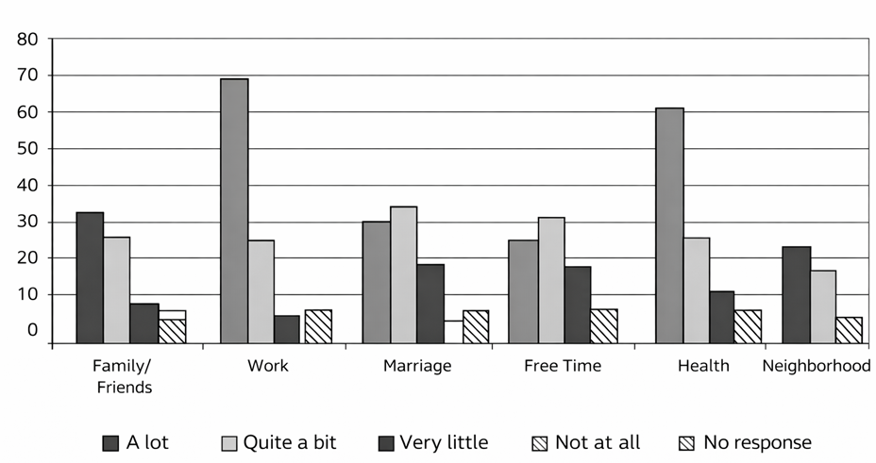
Figure 1: Figure caption

All figures should be numbered, centered and arranged horizontally with regard to the text. Figures should not exceed the margins of the text. Figures’ captions should be placed under them, in italic and be centered and underlined. Leave one line between the figure’s caption and the text that follows. Figures should be included in high quality in order to ensure their good reproduction during printing. In graphs created with spreadsheets (e.g. Excel) gradient shades of gray should be selected so that they can be clearly distinguished in black and white printing.

Tables should be cited in text and be integrated as close as possible to their point of reference. Each table’s formatting should be similar to the table presented in this template (see Table 1), without using any vertical borders. All tables should be numbered. Tables’ captions should be placed above tables, in Italic and be centered and underlined. Leave one line between the table and the text that follows.

Table 1: Table caption
No. | Text | Percentage  %
1 | Text | 17.3
2 | Text | 37.3
3 | Text | 28.6
4 | Text | 20.6

In case, a large figure or table, that exceeds the text’s margins, needs to be included, a new section should be created, using landscape orientation, without a header.

Footnotes
Footnotes should be avoided. However, footnotes that are necessary should be inserted in the text using consecutive numbers in superscript format. Footnotes should be written, at the bottom of the page, in Aptos, 9 pts font size, in single line spacing.

Footnotes should be also separated from the text with a horizontal line not exceeding the middle of the page. Above and below the line, a blank line must be entered.

Acknowledgements
Acknowledgements may be included at the end of the main text and before the section “References”.

References-Bibliography
Bibliographical references should be in line with the APA (American Psychological Association) style. Information about APA style can be found here: APA References Style.pdf. References should be cited in the text by name and not by number. The surname of the author(s) should be mentioned along with the year of the article or book, (e.g. Depover, Sarantos et al., 1996). If there are more than three authors, the surname of the first author should only be cited followed by et al. (e.g. Smith et al., 1998).

All bibliographical references should be listed, in alphabetical order, in the “References” section, which is not numbered. International references should be listed first followed by Greek references. For the same author, references are listed in chronological order.

References to journals should include: Surname and initials of the name of the first author, name initials and surnames of all other authors, year of publication (in parenthesis), paper title, journal title (in Italic), number of volume and pages.

References to books should include: Surname and initials of the name of the first author, name initials and surnames of all other authors, year of publication (in parenthesis), title of book (in Italic), publisher and place of publication.

